What is MCP ??
06.01.2026

MCP means “Model Context Protocol.”
It’s like a universal adapter for AI. It helps AI apps (like chatbots) connect easily to outside things—files, tools, or databases—without needing special setups.

🧩 Simple way to think of MCP
- Universal adapter: Just like a USB-C port lets devices plug into anything, MCP lets AI plug into different systems.
- Connects AI to data: It helps AI read files, use calendars, or talk to databases.
- Makes AI more useful: Without MCP, AI is stuck in its own box. With MCP, it can reach out and do more.
- Created by Anthropic: A company working on AI introduced it in late 2024.

⚡ Example
Imagine you have an AI assistant.
- Without MCP → it can only chat.
- With MCP → it can also check your calendar, open files, or run tools.
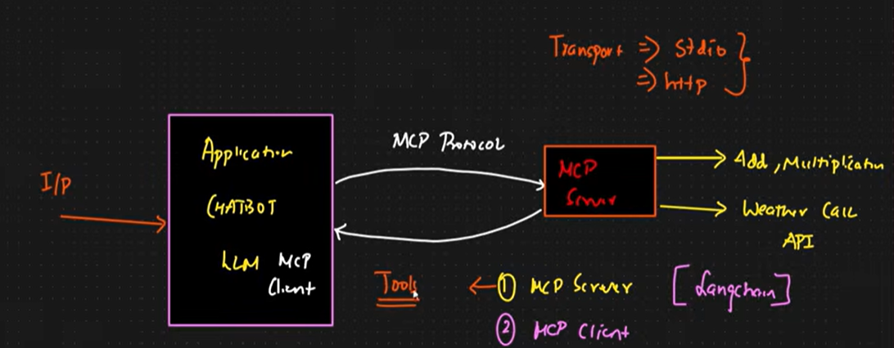

MCP Server , MCP Client
- MCP Server = the tool or data source (like a calendar, database, or code runner).
- MCP Client = the connector that lets your AI app talk to that server.

🖥️ MCP Server
- Think of it as the service provider.
- Example: A calendar server that knows your meeting schedule.
- It offers data or actions (like “get today’s events”).

📱 MCP Client
- Think of it as the translator/connector inside your AI app.
- Example: Your AI assistant has a calendar client that connects to the calendar server.
- It asks the server for info and brings it back to the AI.

⚡ Simple Example
Imagine you’re using an AI assistant:
- You say: “What’s on my calendar today?”
- The MCP Client in the assistant talks to the MCP Server (calendar).
- The server replies: “Meeting at 10 AM.”
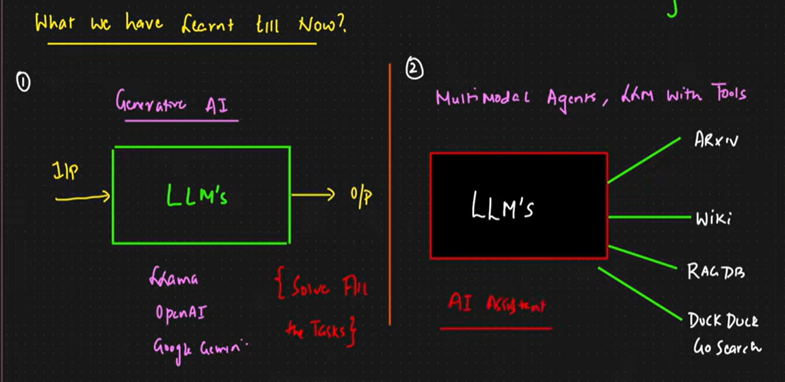
- The client delivers that answer back to the AI, so the AI can tell you.
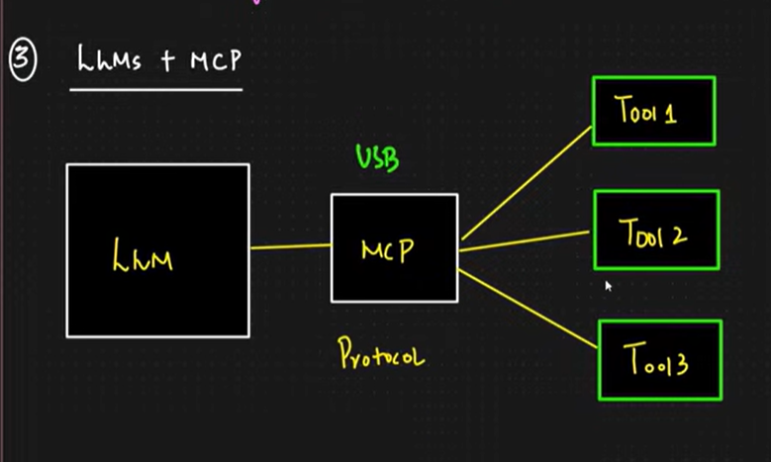
MCP acts like a USB hub for AI—it lets the LLM plug into many tools easily using one shared protocol. Simple, modular, powerful.
It's just a protocol over which LLM makes calls to the tools and tools give answers to the LLM using that same MCP protocol.

Internally in the MCP host , we create Clients.

⚡ Example
Imagine an AI coding assistant called Cursor:
- Cursor is the MCP Host.
- It has an LLM inside.
- It uses MCP to connect to tools like:
  - File search
  - Code execution
  - GitHub access
So when you ask Cursor: “Run this Python code,”
- Cursor (host) uses MCP client to talk to a code runner tool (MCP server).
- You get the result instantly.

One MCP host can have a link with any no. of MCP servers.
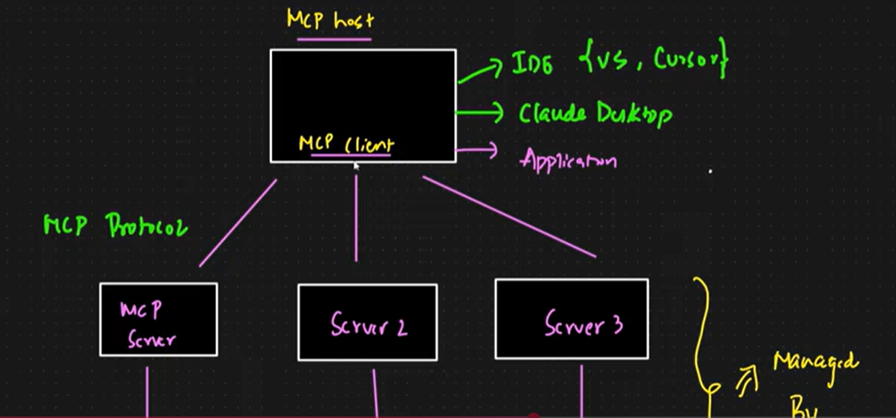

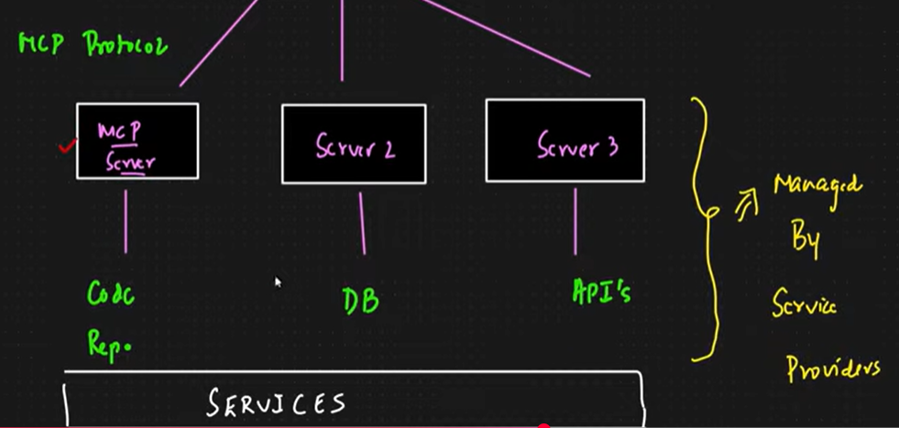

Benefits of MCP :

⚡ Simple Example
Without MCP:
- Each AI app must build its own special connector to talk to a calendar, database, or file system.
With MCP:
- The calendar tool is written once as an MCP server.
- Any AI app with an MCP client can use it immediately — no extra coding.

🚀 Benefits of MCP
- One common protocol: Instead of every AI app inventing its own way to connect, MCP gives a standard “language.”
- Plug-and-play tools: Tools built once can be reused across many AI apps without rewriting code.
- Less custom wiring: Developers don’t need to build unique integrations for each app → saves time.
- Scalability: Easy to add new tools; the AI just plugs them in like USB devices.
- Interoperability: Different AI hosts (apps) can share the same tools because they all speak MCP.
- Security & control: MCP defines clear boundaries between AI and tools, reducing messy or unsafe direct connections.
- Updates in one do not affect the whole , any update in any app — as no code , then no change in integration of the tool , everything remains as usual.

